**Q1: Printing an array into Zigzag fashion. Suppose you were given an array of integers, and you are told to sort the integers in a zigzag pattern**

**Code:**

<html>

<head>

<script>

function zigzag()

{

var n = Number(prompt("enter size"))

var arr = new Array(n)

for(var i=0;i<n;i++)

{

arr[i]=Number(prompt("enter element"))

}

var temp;

var flag=true;

for(var i=0;i<=n-1;i++)

{

if(flag)

{

if(arr[i]>arr[i+1])

{

temp=arr[i];

arr[i]=arr[i+1]

arr[i+1]=temp;

}

}

else

{

if(arr[i]<arr[i+1])

{

temp=arr[i];

arr[i]=arr[i+1]

arr[i+1]=temp;

}

}

flag=!flag

}

for(var i = 0; i < n; i++){

document.write(arr[i]);

}

}

</script>

</head>

<body>

<input type="button" onclick="rearrange()" value="rearrange positive and negative numbers">

</body>

</html>

**Output:**

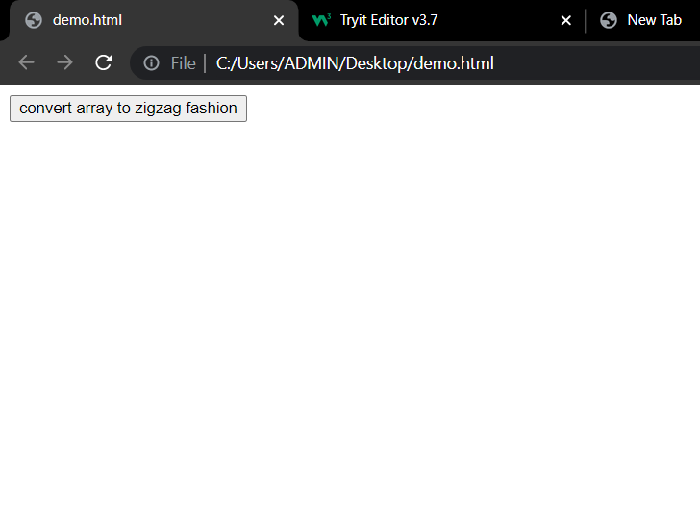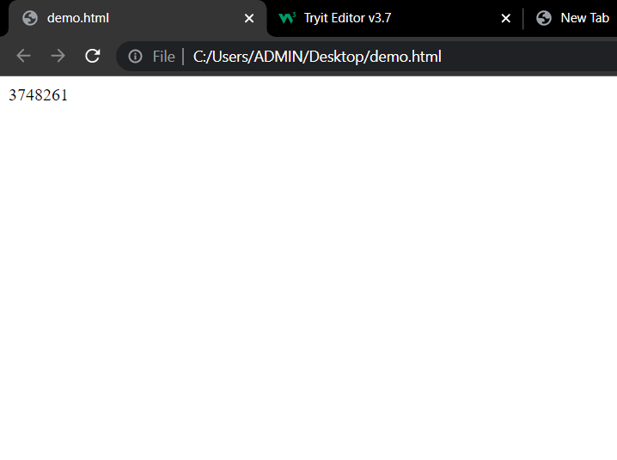

**Q2: The problem to rearrange positive and negative numbers in an**[**array**](https://www.faceprep.in/procoder/knowledgebase/introduction-to-arrays)**.**

**Code:**

<!DOCTYPE html>

<html>

<head>

<script>

function rearrange()

{

var temp;

var n = Number(prompt("enter size"));

var arr = new Array(n)

for(var i=0;i<n;i++)

{

arr[i]=Number(prompt("enter element"));

}

var low=0

var high=n-1

while(low<=high)

{

if(arr[low]>0)

{

temp=arr[low]

arr[low]=arr[high]

arr[high]=temp

high=high-1;

}

else{

low=low+1;

}

}

for(var i = 0; i < n; i++){

document.write(arr[i]);

}

}

</script>

</head>

<body>

<input type="button" onclick="rearrange()" value="rearrange positive and negative numbers">

</body>

</html>

**Output:**

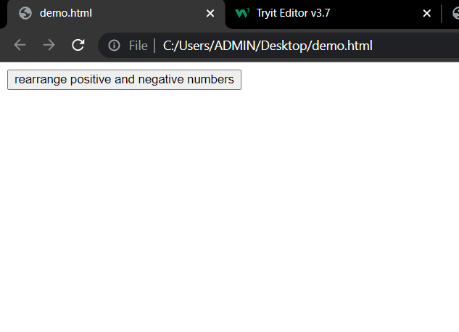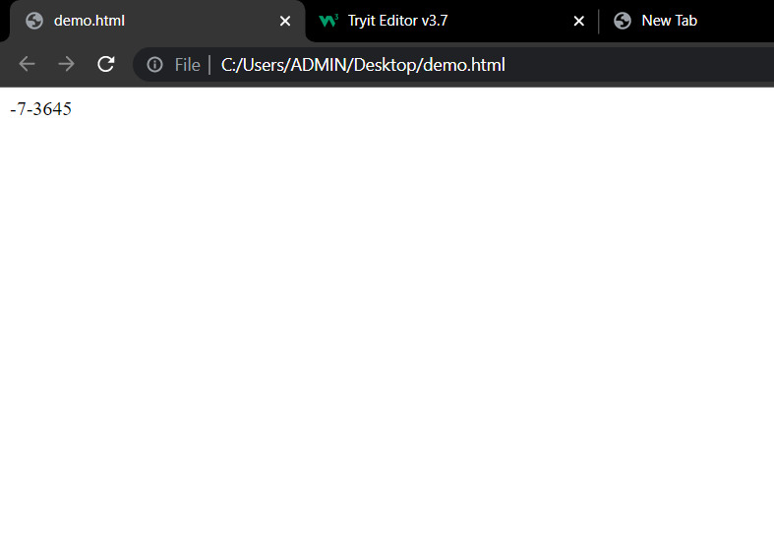

**Q4. Write a Java script program to o find all pairs of elements in an Array whose sum   
 is equal to a given number.**

**Code:**

<!DOCTYPE html>

<html>

<head>

<script>

function findpairs()

{

var n = Number(prompt("enter size"));

var arr = new Array(n)

for(var i=0;i<n;i++)

{

arr[i]=Number(prompt("enter element"));

}

var sum = Number(prompt("enter target"));

for (let i = 0; i < n; i++)

for (let j = i + 1; j < n; j++)

if (arr[i] + arr[j] == sum)

document.write("(" + arr[i] + ", "+ arr[j] + ")" + "<br>");

}

</script>

</head>

<body>

<input type="button" onclick="findpairs()" value="Find pairs">

</body>

</html>  
 **Output:**

